The demo shows how to build and deploy a Docker Engine, run Docker commands, and install Docker Swarm.

Step 1: Update Software Repositories

Run the following command on the terminal:

sudo apt-get update

### Step 2: Uninstall Old Versions of Docker

Before proceeding, uninstall the old Docker software and use the following command:

sudo apt-get remove docker docker-engine docker.io

### Step 3: Install Docker

To install [Docker on Ubuntu](https://www.simplilearn.com/tutorials/docker-tutorial/how-to-install-docker-on-ubuntu), run the following command:

sudo apt install docker.io

### Step 4: Set-up Docker

Set-up and run Docker service by entering the following commands in the terminal window:

sudo systemctl start docker

sudo systemctl enable docker

### Step 5: Verify Docker Version

To check the installed Docker version, enter the following command:

sudo docker --version

### Step 6: Run Docker Container

To run a Docker container, it’s important to pull a Docker Image (such as MySQL) from Docker Hub.

sudo docker pull mysql

sudo docker run -d -p0.0.0.0:80:80 mysql:latest

Now, Docker pulls the latest MySQL image from the hub.

List down all the available Docker images on your machine by using the following command:

sudo docker ps -a

### Step 7: Create Swarm

Here, create a cluster with the IP address of the manager node.

sudo Docker Swarm init --advertise-addr 192.168.2.151

Subsequently, you should see the following output:

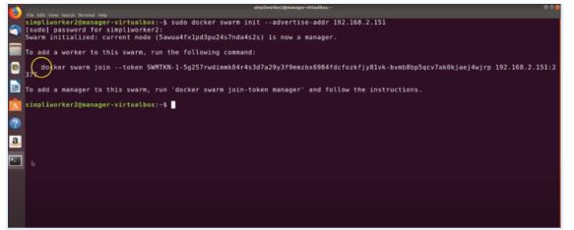

Manager Node

This means that the manager node is successfully configured.

Now, add worker node by copying the command of the “swarm init” and paste the output onto the worker node:

sudo Docker Swarm join --token SWMTKN-1- xxxxx

Your worker node is also created if you see the following output:

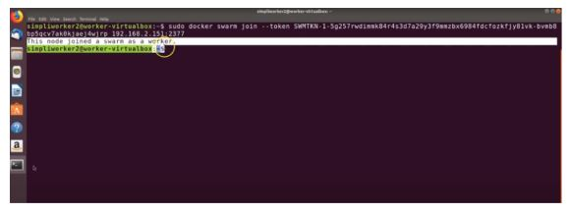

Worker Node

Now, go back to the manager node and execute the following command to list the worker node:

sudo docker node ls

Here, you must see the worker node in the following output:

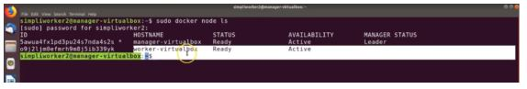

Swarm Cluster - Docker Swarm

The above image shows you have created the Swarm Cluster successfully. Now, launch the service in Swarm Mode.

Go to your the manager node and execute the command below to deploy a service:

sudo docker service create --name HelloWorld alpine ping docker.com

By executing the above command, you can access the HelloWorld file from the remote system.

To see the output, you can check the services with the following command:

sudo docker service ls

Finally, you should be able to see the following output:

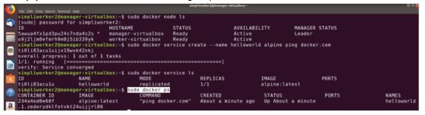

Service Created - Docker Swarm

And that’s it! Well done, you have successfully installed and configured the Swarm cluster on Ubuntu 16.04. Also, whenever required, you can effortlessly scale your application with no performance issues.

This brings us to the conclusion of the article what is Docker Swarm